**­**

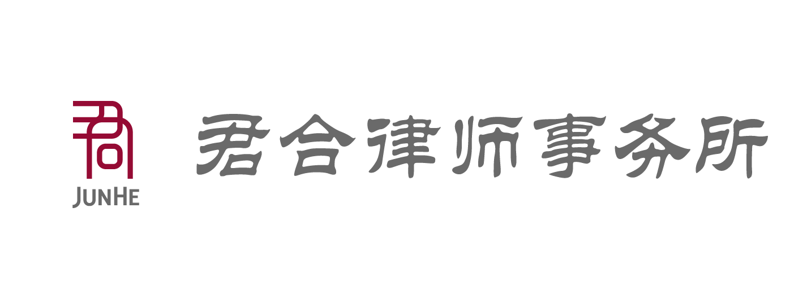

**ALB: 2015 TOP GENERAL COUNSEL IN CHINA SUBMISSION FORM**.

**“ALB:2015最佳总法律顾问”评选表格**

Please provide responses and other important details in the blanks in respect of the General Counsel of your company. Self nomination is welcome. 请填写贵公司总法律顾问的相关信息。欢迎自荐。

This template is a guideline and if you would like to submit using a different format, we will accept those submissions as well. 以下表格格式供参考。如有更多补充信息，您也可以通过其他格式提交

The deadline for submission is **May 20, 2015 6:00 pm (Beijing time).**

提交报名截止时间为**2015年5月20日18:00**（北京时间）

**Please send submissions to:** [**shangjing.li@thomsonreuters.com**](mailto:shangjing.li@thomsonreuters.com)

**请于截止日期之前将问卷以电子邮件方式发送到:** [**shangjing.li@thomsonreuters.com**](mailto:shangjing.li@thomsonreuters.com)

**Basic details**

**基本信息**

|  |  |  |  |
| --- | --- | --- | --- |
| **Name of General Counsel**  **总法律顾问 姓名（或公司的法律事务最高负责人姓名与职务）** |  | **Company Name**  **公司名称：** |  |
| **Number of years in the Company**  **在公司工作时长：** |  | **Number of years as General Counsel:**  **担任总法律顾问时长：** |  |
| **Highest degree and school:**  **最高教育程度和毕业院校：** |  | **Number of people in the legal team**  **管理法务团队人数：** |  |
| **Contact person 联系人姓名** |  | **tel/email联系方式：** |  |
| **Company address**  **公司地址：** |  |  |  |

|  |  |
| --- | --- |
| **Please list the GC’s most significant achievements or initiatives introduced into the company．**  **请列举该总法务在贵公司的主要成就或在公司启动的重大项目：** |  |
| **Please list any significant work matters that the GC took part in the last 12 months**  **过去一年中总法务的主要工作内容 ：** |  |
| **Please list any significant accolades the GC has received for work in the form of company or public recognition, awards etc.**  **该法务个人曾获得的公司内部或外部奖项：** |  |
| **Previous work experience in the legal industry**  **之前跟法律相关的工作经验和成就：** |  |
| **Other relevant information (including, but not limited to, pro-bono work, charity work, social service etc.)**  **其他提名理由（包括但不限于法律援助，慈善活动，社会公益工作等）** |  |
| **Motto 座右铭** |  |