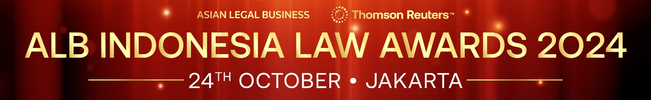

SUBMISSION FORM – INDIVIDUAL CATEGORIES

Read the Research Methodology Summary before filling out the submission form.

Deadline for submissions – 2 August 2024 (Friday)
Send the completed forms to albawards@thomsonreuters.com

This form is for one category only. To submit another category, please complete a new form.
Save this form using the format: ALBILA2024-Category-Organisation
Example: ALBILA2024-Managing Partner of the Year-ABC Law Firm

Please send the submission form in Word format and do not convert it to PDF.

CHOOSE A CATEGORY HERE
Name
A. BASIC INFORMATION
Law firm/company
Position
No. of years in the current position
No. of people being managed, if applicable
(Specify number of lawyers and non-lawyers.)
Age & birthday (required for Young Lawyer of the Year category)
Country of residence (Confirm that the candidate is based in Indonesia.)
Current professional, academic, government, and community affiliations (incl. memberships/positions.)

Contact Information
(email and phone number of the nominee)

B. KEY WORK HIGHLIGHTS
KEY WORK NO. 1: (Indicate heading here)
Completion date:
Description (max. of 500 words)

KEY WORK NO. 2: (Indicate heading here)
Completion date:
Description (max. of 500 words)

KEY WORK NO. 3: (Indicate heading here)
Completion date:
Description (max. of 500 words)

C. OTHER ACHIEVEMENTS (max. of 500 words)

OPTIONAL: IN-HOUSE TEAM NOMINATIONS
Any in-house teams you’d like to nominate?

In-house category:
Company:
General Counsel/Head of Legal:
Email & tel. no.:
Reason for nomination:

